First Quarter - 2020

FITNESS PARK DEDICATED IN MEMORY OF CAROL SHEA BARBER

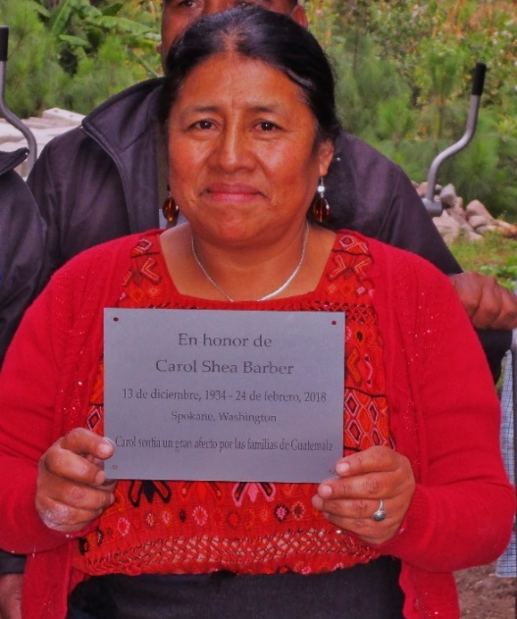
The placard reads” En honor de Carol Shea Barber… Carol sentia un gran afecto por las familias de Guatemala. ” This memorial will be installed at the recently completed fitness park in Xe’ul as a lasting tribute to the late Carol Shea Barber, who passed away in 2018. The park was an idea presented by Adela Tambriz, program manager of Family to Family, for recreational use by families in the skills training classes. During break periods, the men and women sitting behind looms or sewing machines needed to stretch. Adela thought the outdoor exercise equipment would serve that purpose while also providing a little “fun.” Donors who knew Carol helped to make this dream a reality by contributing to Family to Family in her honor. In 1990, Carol and her husband, Dr. Bill Barber, helped to drive and deliver a much needed ambulance to the medical clinic in Nahuala and a school bus to the remote community of Tzamjuyub. The two week 4,000 mile journey was no easy task, but the Barbers along with 16 other volunteers got the job done. Many thanks to those who contributed to this project in memory of Carol. Your generosity fulfilled a dream for the poor served by Family to Family to have a place to forget the hardships they face on a daily basis and enjoy the camaraderie of each other in a beautiful setting.
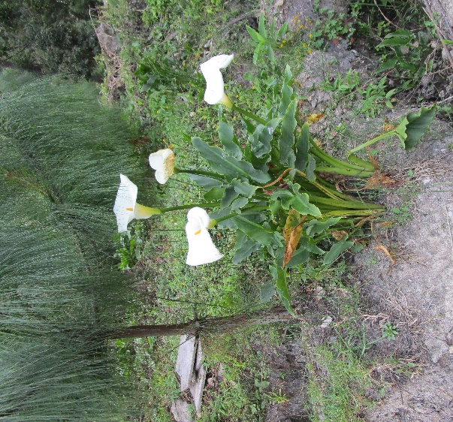
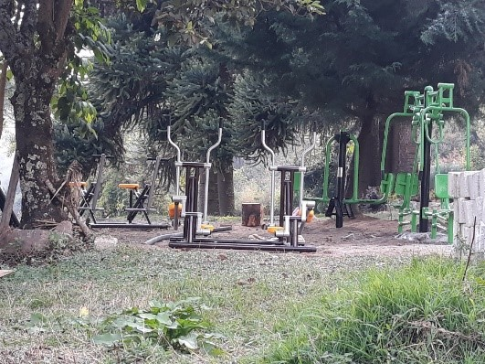

Projects, Projects and More Projects

Roger and Miriam Devaney, FTF Directors, visited several project sites in November. The first stop was in Xe’ul, also known as an “agropecuaria” which refers to land used for growing crops and raising animals. The swine holding area contained at least a dozen healthy-looking pigs that will eventually weigh up to 200 pounds or more. Swine production can be lucrative considering each sow can produce 2-3 litters per year with 8-12 pigs in each litter. The smaller feeder pigs are being fed a fortified corn and soybean mixture until they reach about 80-100 pounds and will then be sold. The profits will be used to purchase even more pigs. The second lot will be bred, weaned and given to families in the swine raising program. Four families already used the pork they produced to make sausages. They learned that the sausage brought in more profit than selling the meat outright. The holding pen displayed a wooden sign overhead that spelled out the word pig in Spanish, Quiche’ and English.
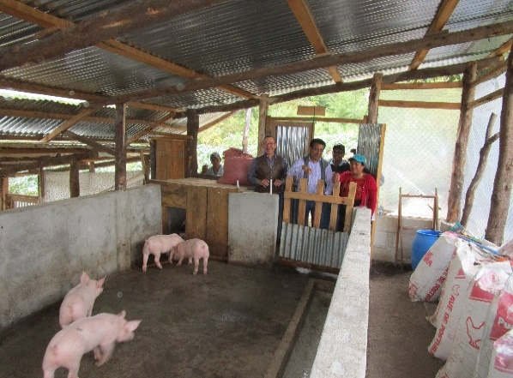

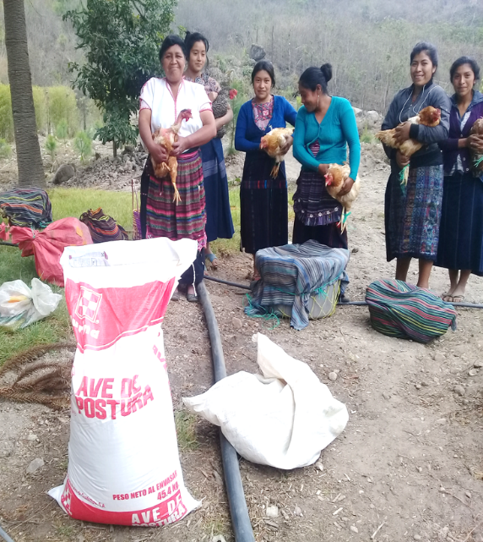
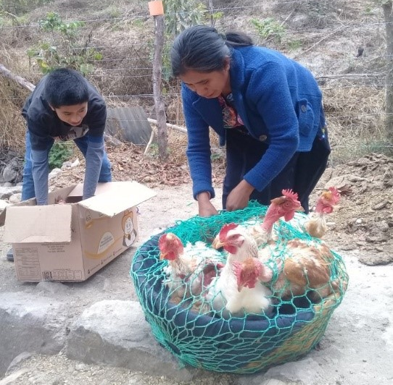
The second stop was the chicken house. Poultry production is very popular with families as the income derived from selling the eggs and meat is enough to sustain a typical family. In 2019, a dozen families received chicken feed, wood and wire for construction of coops and ten hens/roosters. Adela plans to expand to 40 families in 2020.

